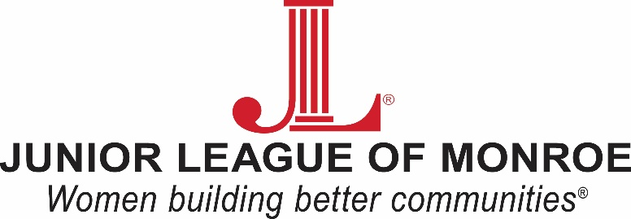

2021-2022 MINI-GRANT APPLICATION

An electronic copy of this fillable form is available on www.jlmonroe.org (Community/Tools and Literacy for Children(TLC): Task Force/Junior League Grant Application 2021). Applications must be typed and turned in by Friday, October 4, 2021 by 5 p.m. Applications may be faxed to (318) 322-3299, mailed or dropped off to the Junior League at 2811 Cameron Street in Monroe.

Grant Applicant(s):​​​​​​​​​​ | Click or tap here to enter text.
Grant Title: | Click or tap here to enter text.
Name of School: | Click or tap here to enter text.
Principal of School: | Click or tap here to enter text.
Principal Email Address: | Click or tap here to enter text.
Grant Applicant(s) Email Address: | Click or tap here to enter text.
Daytime phone number: ​​ | Click or tap here to enter text.

Please check the appropriate category:
☐Monroe City
☐Ouachita Parish
☐Private/Parochial
☐Charter
Please check the appropriate category:
☐Elementary (Prek-5)
☐Middle School (6-8)
☐High School (9-12)

- Project Description: Include what you plan to do, the number of students participating, the duration of the project, if project could be used for subsequent classes/grades, estimated start date, potential applications and any other pertinent information. Feel free to attach any additional information or supporting documents.
Click or tap here to enter text.
- Objectives of Project:
Click or tap here to enter text.
- Equipment, Materials & Supplies: List each item separately and include source, vendor and price. If JL Mini-Grant Award does not cover entire cost, please explain how project will be completed or from where additional funds will be contributed.
Click or tap here to enter text.
- Higher Order Thinking: Describe the teaching techniques you will use with this project to challenge your students to a higher level of thinking. How will this project expand the student’s view and impact their education?
Click or tap here to enter text.
- Student Engagement: Describe how students will be intellectually engaged with this project. Describe the learning tasks and activities. Include the number of students who can be engaged as a results of this project.
Click or tap here to enter text.
- Parents and Community: Describe how you will involve parents and the community with this project in your teaching.
Click or tap here to enter text.

Applicant(s) Signature: _______________________________________

Principal Signature: __________________________________________

By signing this application, the applicant(s) and their principal agree that any funds received will be used for the purpose stated in this application. All grant recipients must complete an end of year report before they can be re-considered for the next calendar year mini-grant. The end of the year report should be emailed and delivered to jrleague@jlmonroe.org 2811 Cameron Street, Monroe (off Lamy Lane) by April 29, 2022.

